
Tripoli Motor Testing Division
223 NC Highway 54 West
Chapel Hill, NC 27514
(919) 357 5681 (c)
June 3, 2002

Gary Rosenfield
RCS Rocket Motor Components, Inc.
2113 West 850 North Street
Cedar City, UT 84721

Dear Mr. Rosenfield,

The Q-jet by Aerotech E35W single-use motor was tested on April 29, 2022 and complies with NFPA 1125. The motor is certified for hobby rocketry use by the members of the Tripoli Rocketry Association and all approving organizations with reciprocal certifying agreements.

Motor Manufacturer RCS Rocket Motor Components, Inc.
Manufacturer’s Designation {E35-5,8,11W } [single use]
Propellant White Lightning
TMT Nomenclature 39 E34

Diameter 0.934” 23.73 mm
Overall Length 4.440” 112.77 mm
Outside the MMT 0.191” 4.85 mm

Loaded Mass 0.121 lb 55.09 g
Propellant Mass 0.056 lb* 25.4 g*
Burnout Mass 0.054 lb 24.54 g
* = data provided by manufacturer

Burn time 1.079 ± 0.056 sec

Total Impulse 8.853 ± 0.126 lbf.s 39.38 ± 0.56 N.s
Max Impulse 9.882 ± 0.997 lbf 43.96 ± 4.43 N
Average Impulse 7.789 ± 0.284 lbf 33.81 ± 3.11 N
Number of Motors Tested 11

Nominal Measured
Delay Time Data 5 s 4.956, 4.431, 4.694 s
8 s 7.207, 7.157, 6.434, 6.856 s
11 s 10.720, 9.931, 9.081, 9.046, 9.558 s

Casing Temp. [NFPA 1125 7.4.1] Passed

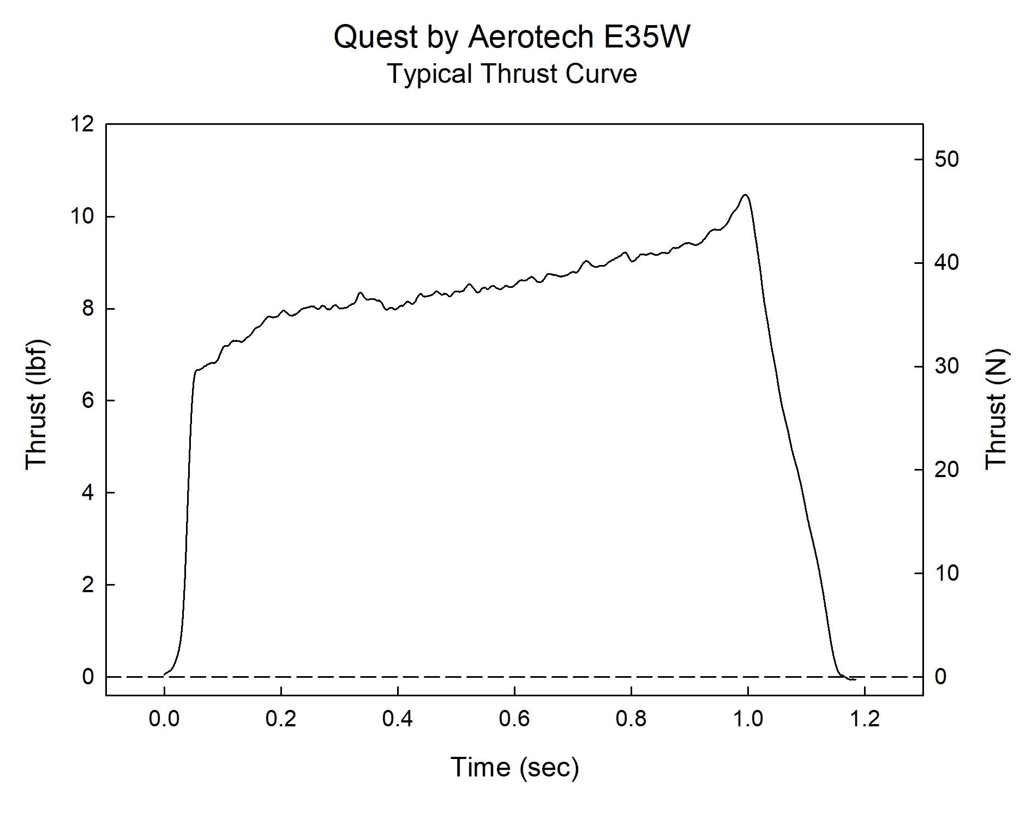

Sincerely,

Alan C. Whitmore
Chair, Tripoli Motor Testing

